Manual Verification of the results for the Balancing Method

Output Generated by the code

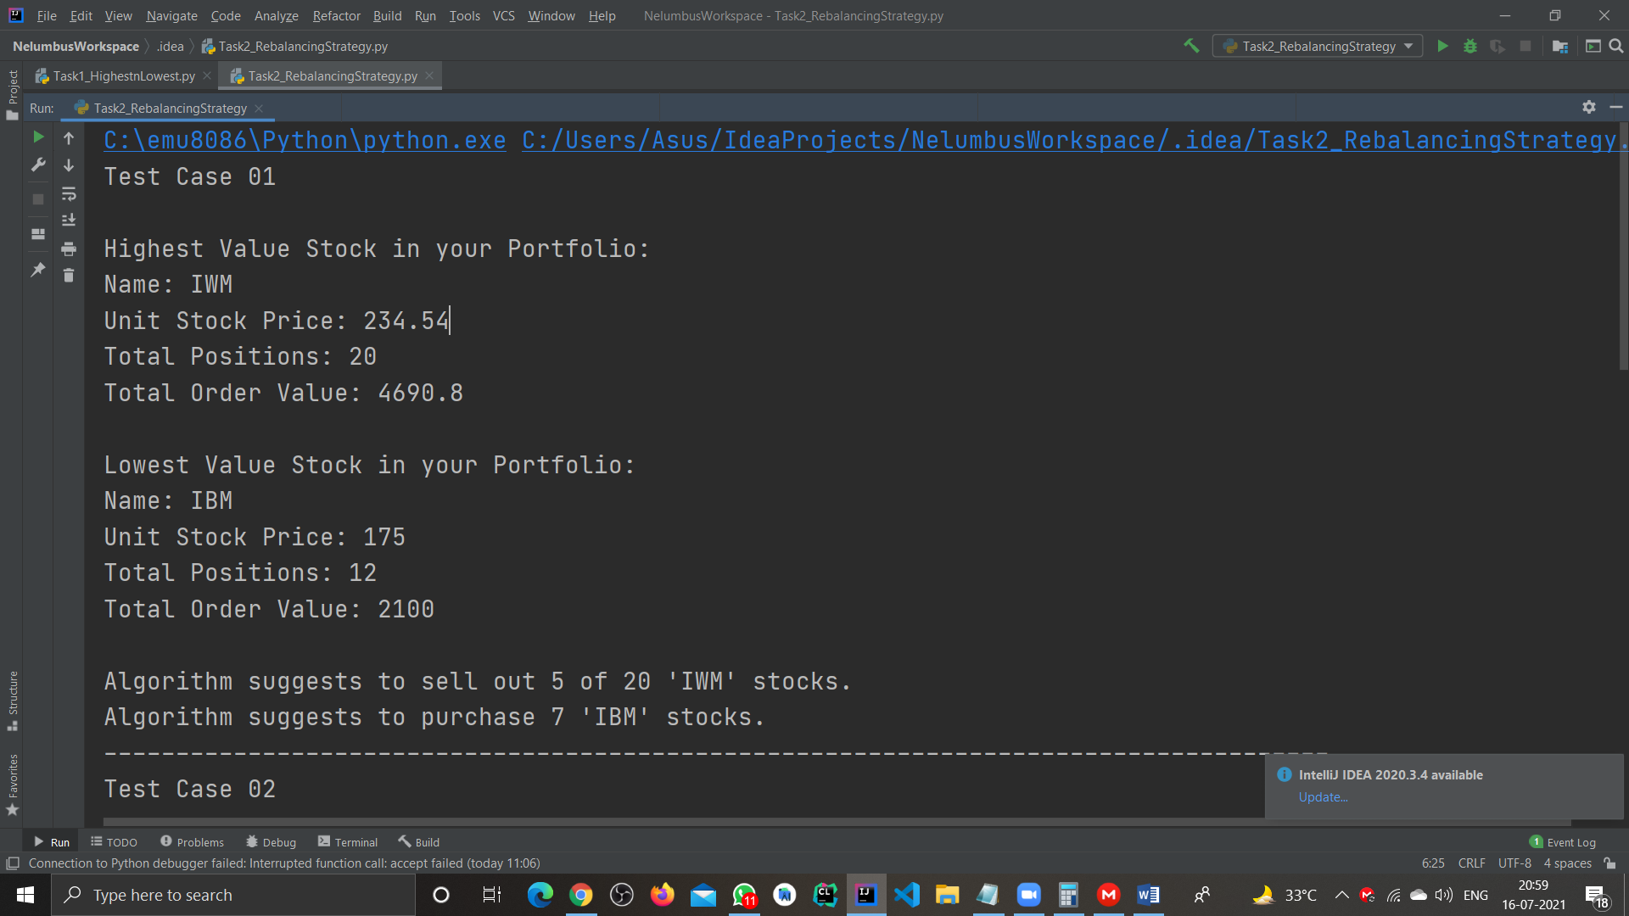

Test Case 01

Total Order Value for the stocks

|  |  |  |  |  |
| --- | --- | --- | --- | --- |
| Stock Name | Unit Stock Value | Stock Positions | Total Order Value | Remarks |
| AAPL | 149.15 | 15 | 2237.25 | NIL |
| IWM | 234.54 | 20 | 4690.8 | Highest Valued |
| IBM | 175 | 12 | 2100 | Lowest Valued |

Average of the Highest and Lowest Order Value = (4690.8 + 2100)/2 = 3395.4

How many stocks of Highest Order Valued Stock(‘IWM’) should be sold?

Difference between Highest Order Value (‘IWM’) and Average Order Value = 4690.8 – 3395.4 = 1295.4

IWM stocks to be Sold = 5

As, 234.54 * 5 = 1172.7

How many stocks of Lowest Order Value(‘IBM’) should be purchased?

Difference between Lowest Order Value (‘IBM’) and Average Order Value = 3395.4 - 2100 = 1295.4

IBM stocks to be Purchased = 7

As, 175 * 7 = 1225